Name of Equipment | Description and Application | Physical Specifications | Utility Specifications | Remarks
19 litre Parr stirred digester – floor standing DI-201 | The digester is used to affect sawdust biomass fractionation at a pilot scale. It is an electrically heated digester. The maximum operating pressure is 55 bar, and the maximum operating temperature is 271ᵒC. It is operated in batch mode. | 2.5 (L) x 2.4 (W)x2.4 (H) metres  Note: Space for the accommodation of free movement for operators/maintenance must be factored in. | Water and compressed air (6 bar) supply systems  Nitrogen gas supply system  Electrical information:  220V | Photo and PID have been provided (Fig 1&2 and 3)  Manual /drawings from the OEM are available
Low Consistency refiner system – floor standing | The LC refiner system consists of two agitated tanks (with a capacity of 400 ℓ each), piping and fittings, and a positive displacement pump. Used for multi-purpose, e.g., as a mixer | 3.8 (L) x 3.5 (W)x 3.2 (H) metres.  Note: Space for the accommodation of free movement for operators/maintenance must be factored in.  Should also be provided with an option for disposing of the content and/or preventing the spillage ( during a process upset) | Water and compressed air (6 bar) supply system  Electrical information:  380V | manual or drawings not available  PFD/ PID developed in the house has been provided (Fig3)
Screen –flow standing – Floor standing SN-101 | Vibrating screen separates wood chips feeds containing oversize, undersize and fine chips. | 1.9 (L) x 1.6 (W)x 1 (H) metres  Note: Space for the accommodation of free movement for operators/maintenance must be factored in. | Electrical information:  220V | No manual or drawings are available  PFD/ PID developed in-house has been provided (Fig 3)
Bench-scale biochar unit –Floor standing VP-402 | Bench scale biochar unit used to convert biomass into biochar. The unit is incorporated with the oxidizer, which oxidizes the flue gases before being released into the atmosphere. It operates at a temperature range of 200-1000 ⸰C. Note: it has no gas condenser unit, as indicated in your preliminary PFD. Maybe you need to include a provisional wood vinegar recovery system that may be incorporated later. | 3 (L) x 1(W)x 2.1 (H) metres  Note: Space for the accommodation of free movement for operators/maintenance must be factored in. | As per quote specifications | For PFD/PID, refer to drawings from the OEM which has been provided to you  For additional information, liaise with Oldnall William  william@thermopower.co.za  0113162184
Laboratory wood chipper – Floor standing WC-101 | The chipper is used to turn wood discs into woodchips (size reduction). | 1.7 (L) x 1.5 (W)x 1.3 (H) metres.  Note: Space for the accommodation of free movement for operators/maintenance must be factored in. | Electrical information:  220V | No manual or drawings are available  PFD/ PID not applicable for bench-scale equipment
Hammer mill – Floor standing MI-101 | The hammer is used for biomass size reduction) | 1.2 (L) x 1.2 (W)x 1.4  (H) metres.  Note: Space for the accommodation of free movement for operators/maintenance must be factored in | Electrical information:  220V | No manual or drawings are available  PFD/ PID not applicable for bench-scale equipment
Willey mill MI-102, shaker and pulp fluffer | The Willey mill is used for turning woodchips/biomass into sawdust (size reduction). The shaker is used for particle size classifications, whereas the pulp fluffer turns the pulp into a fluffer. | Mounted on the table  1.9 (L) x 1.3 (W)x 1.6  (H) metres.  Note: Space for the accommodation of free movement for operators/maintenance must be factored in | Electrical information:  220V | No manual or drawings are available  PFD/ PID not applicable for bench-scale equipment
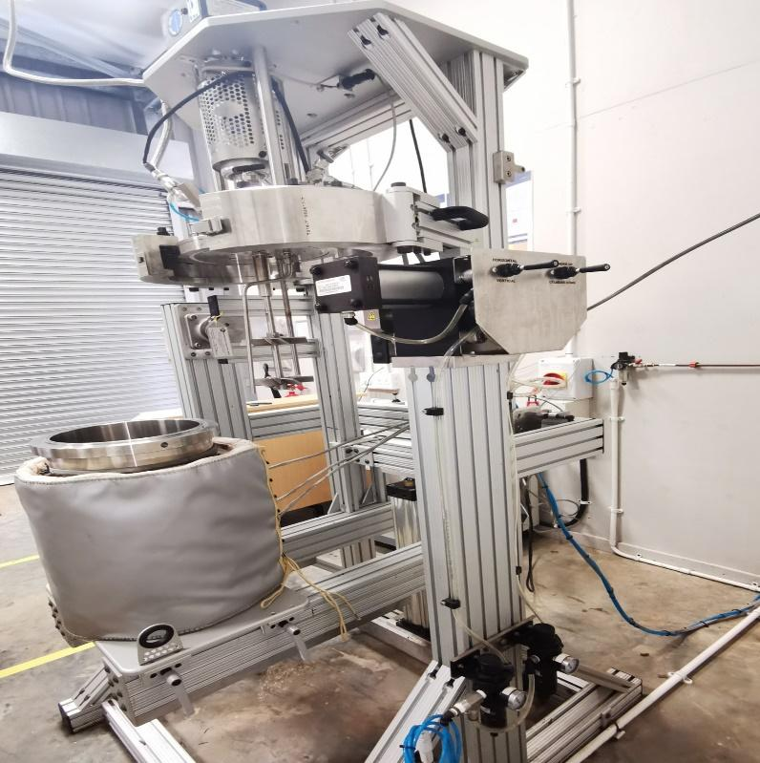
Figure 1: Parr Stirr Digester

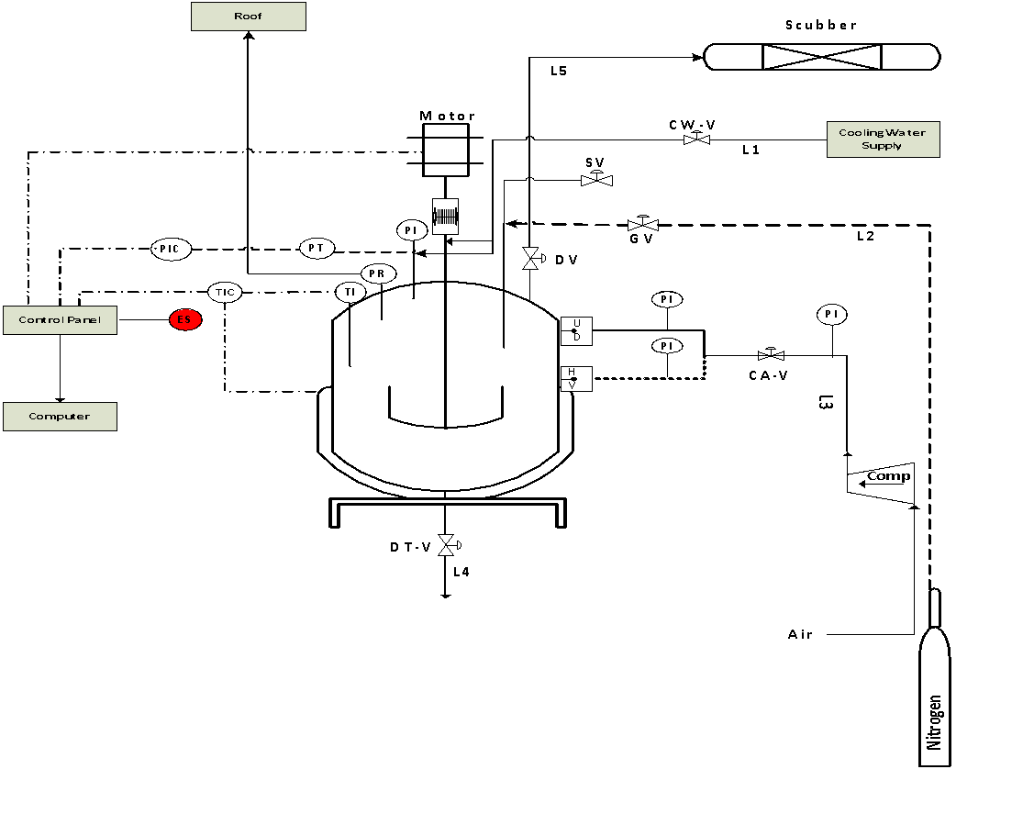
Figure 2: Schematic PID of the Parr Stirred Digester
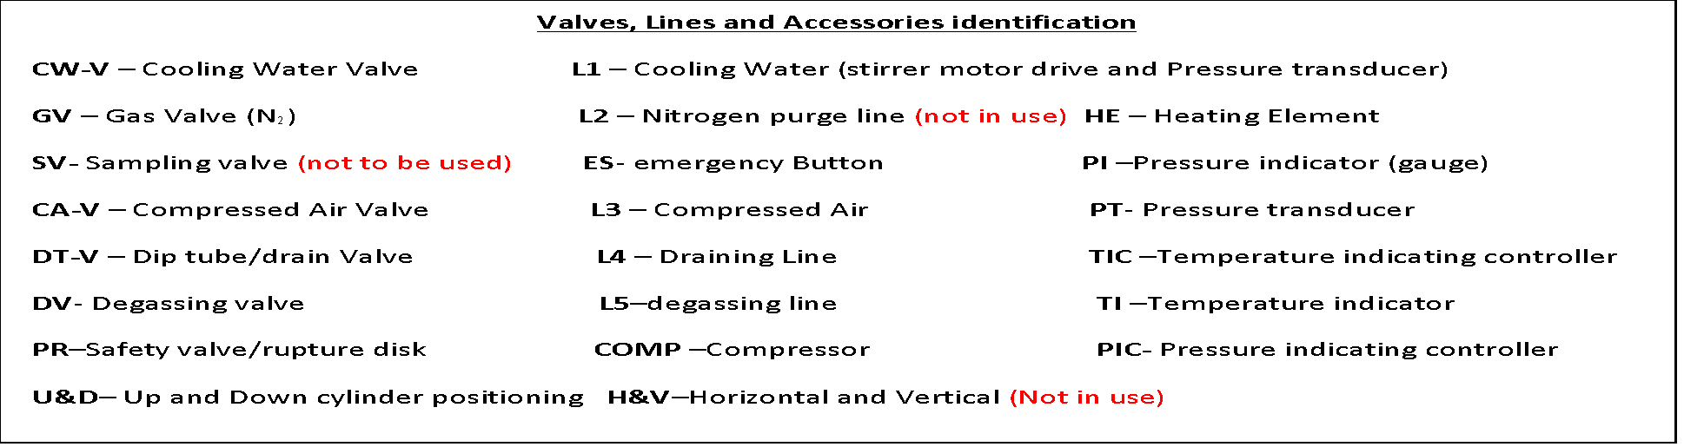
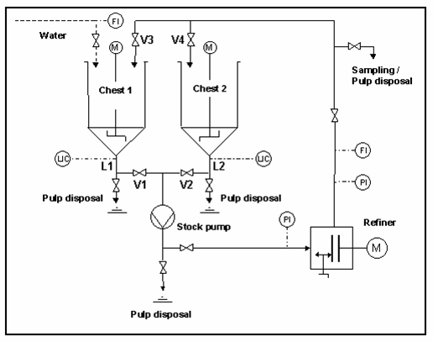
Figure 3: Process Flow Diagram of the Laboratory LC Refiner
Note: V2 and V4: are pneumatic valves. V5, V8, and V10: Are manually operated valves
ADDITIONAL EQUIPMENT WHICH ALSO NEEDS TO BE ACCOMMODATED – EXPANSION PROJECT
Equipment | Description and application | Physical specifications | Utility specifications | Remarks
RDH digester- Floor standing DI-203 | The digester affects wood chips/biomass fractionation or pulping at a pilot scale. It is heated by using steam. For the process, the specification refers to a quote that has been provided to you. Note: It will have features that support rapid displacement heating principles (RDH): four accumulator/receiver tanks, one tank for storing chemicals/solvents, and one tank for storing the extract (approximately 80 L). In addition, it will require a provisional for a separate control room, washing and pulp screening unit, and condensate recovery and treatment units (specifications not available, should be linked with the boiler’s supporting systems) | As per quote specs | As per quote specs | 3D Photo (Fig 5) and PID have been provided.  Manual /drawings from the OEM are not available.  For additional information liaise with Alexander Vos:  alexander@crs-reactor.com  +46(0)303-587 36
300L Flow-through digester- Floor standing DI-202 | The digester is used to effect woodchips/ biomass fractionation at a pilot scale. It is an electrically heated digester. The maximum operating pressure is 8 bar, and the maximum operating temperature is 180ᵒC. It is operated in a batch mode. The digester was manufactured by Metso ND Engineering (Pty) Ltd. It will use steam occasionally (pre-steaming/extraction). Condensate recovery and treatment should be linked with the boiler’s system. | 1.3 (L) x 1.8 (W)x 2.15 (H) metres. An additional height of 2 metres is required to allow loading and offloading digester using an overhead crane.  Note: Space for the accommodation of free movement for operators/maintenance must be factored in. | Water and compressed air (6 bar) supply system  Condensate recovery and treatment system  Electrical information: 380V | Manual /drawings from the OEM are available.  PFD/ PID have been provided (Fig 6).
Steam Generator (Boiler) – Floor standing | Steam Generator (Boiler) to supply steam to RDH digester, and 300 L flow through the digester, pre-steaming, etc. Steam demand for RDH digester pulping operation is estimated at 108 kg/hr. The boiler should be sized to meet all steam demands, specified and the near-future needs. Our initial estimate, done in collaboration with boiler industrial plant Pty Ltd was about 2 tons/hr. It should be supported by demin water and condensate recovery system. | information not available | Information not available | To be conceptualized to meet BIDF operation and safety needs. CSIR Safety Manager and GMR 2.1 should be consulted, e.g., location of the boiler. In our initial discussion, they indicated that the boiler should be hosted in a separate building.
Pilot-scale biochar unit –Floor standing (VP-401) | Pilot-scale biochar unit used to convert biomass into biochar. The unit is incorporated with the cooling tower and oxidizer. The flue gas is cooled in the cooling tower, and after that, they are oxidized before being released into the atmosphere. It operates at a temperature range of 200-1000 ⸰C. Note: it has no gas condenser unit, as indicated in your preliminary PFD. Maybe you need to include a provisional wood vinegar recovery system that may be incorporated later.  The biochar storage shown in your preliminary PFD is perfect. Note: Your preliminary PFD can be further optimized once all the due diligence has been completed. | 3 (L) x 1(W)x 2.1 (H) metres  Note: Space for the accommodation of free movement for operators/maintenance must be factored in. | As per quote specification | For PFD/PID, refer to drawings from the OEM which has been provided to you  For additional information, liaise with Oldnall William  william@thermopower.co.za  0113162184
Waste Paper recycling pilot –Floor standing  Note: Current location not optimal for operation | The waste fibre recycling pilot plant is used for recovering useful fibres from waste papers. It consists of a hydro pulper, three stirred tanks (each tank is provided with a centrifugal pump, manual and solenoid valve), a pulp screening unit, a floatation cell unit, and a waste water storage tank. It is operated in semi-continuous mode | 3.1 (L) x 3.4 (W)x 2.25 (H) metres  Note: Space for the accommodation of free movement for operators/maintenance must be factored in. Furthermore, the tank needs to be at least 0.5 metres above the floor. It also requires a provisional for dewatering equipment e,g., a screw press/belt washer | Water supply system  Hot water supply system  Provisional for discharge of wastewater | PFD/PID (Fig 7). Drawings/manual are available
Hemp cleaner – Floor standing SN-102 | Hemp cleaner used to screen the hemp biomass, e,g., remove contaminates such dust, tiny particles etc. | 1.25 (L) x 0.8(W)x 1.32 (H) metres  Note: Space for the accommodation of free movement for operators/maintenance must be factored in. | Electrical information: Unknown | PID/drawings/manual not available
Valley Beater – Floor standing | Valley beat used for refining the pulp/mechanical treatment of fibres | 1.5 (L) x 0.97(W)x 1.37 (H) metres  Note: Space for the accommodation of free movement for operators/maintenance must be factored in. | Electrical information:  Unknown. | PID/drawings/manual not available
Remarks | - For any issue related to processing engineering, contact directly: Jonas Johakimu, Tel 031 2422316, 0746955677 OR the supplier of the specific equipment (Power Furnaces Pty Ltd, or CRS Rector Engineering).  - For any issue related to electrical, contact directly: Anesh Mistry, Tel 031 2422351 OR the supplier of the specific equipment (Power Furnaces Pty Ltd, or CRS Rector Engineering)

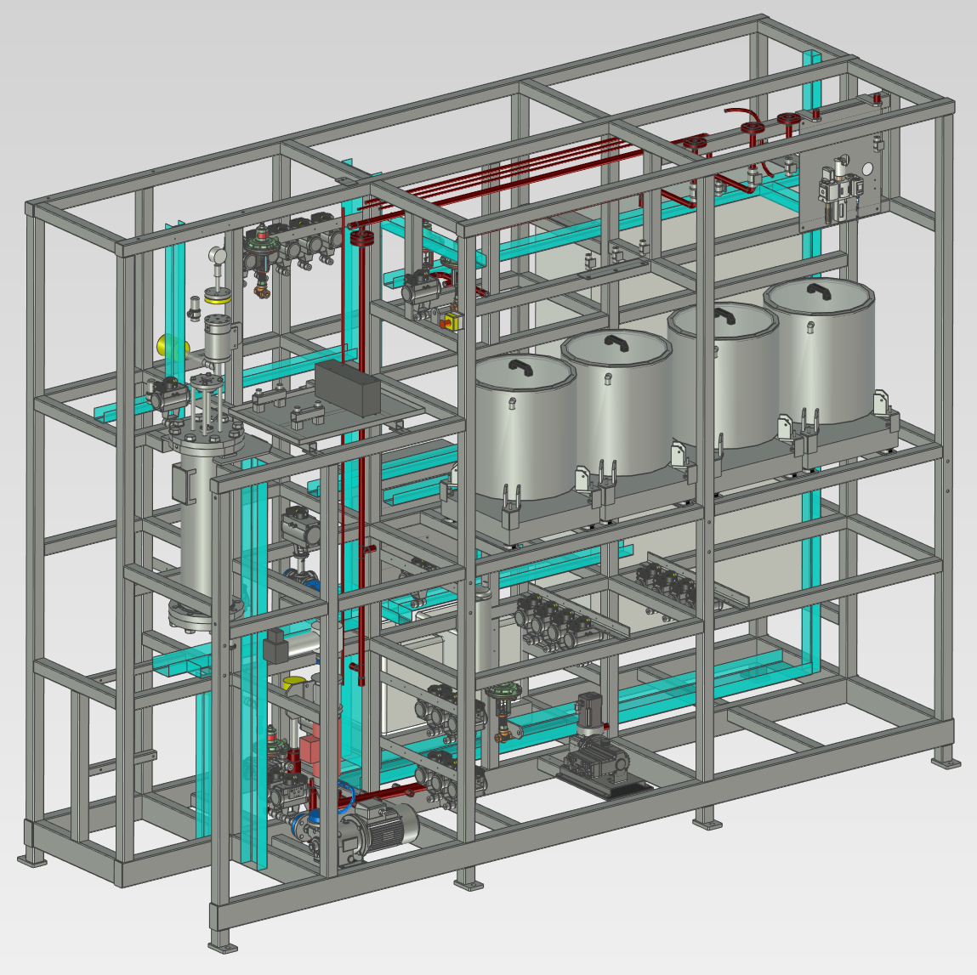
Figure 4: 3D View of RDH Setup

P
PI

T

T

T
TI 1
TI 2
TI 3

TI

Cooling

j jacket

Drain
Vent valve

Cooling jacket
Main water supply line
Safety valves
Figure 5: PFD / PID of the 300lt flow through the digester

Figure 6: P&ID of Waste Fibre Recycling Plant
HOT WATER SUPPLY TANK 2, PIPING, FITTINGS AND VALVES
L1: hot water supply PUMP-02: Pump 2
V1: hot water valve SMT-02: Stirrer 02
FM-02: hot water flow metre T-02: Tank 2
V11: Inlet valve-tank 02
COLD WATER SUPPLY V13: Discharge ball valve-tank 2
L4: Main water supply V14: Solenoid valve pump 3
L5: Cold water Supply-Tank 01 L7: inlet line -tank 02
L8: Cold water Supply-Tank 02
V5: Cold water Valve-Tank 01 FLOATATION CELL, PIPING, FITTINGS AND VALVES
V12: Cold water Valve-Tank 02 PUMP 03: Pump 3
V16: Cold water Valve-Tank 03 FC: Floatation cell
FM-01: Cold water supply flow metre T-06: Tank 06 (froth collection)
L10: Cold water supply tank 3 V15: Inlet valve (Tank 03)
Control panel: (Floatation cell)
RE-PULPER, PIPING, FITTINGS AND VALVES
HP: Hydro pulper
V2: Discharge valve TANK 3 PIPING, FITTINGS AND VALVES
V3: Sampling/bypass valve SMT-03: Stirrer 03
V4: Inlet Valve-Tank 01 PUMP-04: pump 4
L2: Sampling line L12: Outlet line –Tank 03
L3: Discharge line –Tank -01 V17: Solenoid valve Pump 4
T-05: sampling bucket T-03: Tank 03
Control panel: (hydro pulper)
WASTE WATER TANK
TANK 1, PIPING, FITTINGS AND VALVES L13: inlet line-tank 4
T-01: Tank 01 L14: outlet line-tank 4
PUMP-01: Pump 01 T-04: waste water tank
SMT-01: Stirrer 01 PUMP-05: Pump 05
V6: Manual ball valve -Tank 01
V7: Solenoid valve pump 1
L6: Discharge line –Tank 01

SCREEN PIPING, FITTINGS AND VALVES
Coarse mesh screen: (10 mesh)
fine mesh screen: (200 mesh)
V8: Screen inlet valve (Tank 01)
V18: Screen inlet valve from (Tank 03)
V9: Outlet valve from screen
PI: Pressure indicator

