Request for Quotation (RFQ) for the Building Maintenance and Repair at the Cofimvaba Science Centre

RFQ Number: 6229/16/02/2024

Date of issue | 29/01/2024
Compulsory  Site Inspection | Date and Time | 09/02/2024 @ 12h00
 | Address | Comfimvaba Science Centre :Eastern Cape
Last date for submission of enquiries/clarifications | Tuesday, 13/02/2024 @ 16h30
Closing Date and Time | Friday, 16/02/2024 @ 16h30 (late submissions will not be accepted)
RFQ Validity Period | 90 calendar days (Commencing from the RFQ closing date)
Enquiries and submission of proposals | For submission of quotations or any other enquiries:  Email tender@csir.co.za (Please use RFQ No and RFQ Description as subject reference)
CSIR Hours | 08h00 – 16h30

INTRODUCTION

The Council for Scientific and Industrial Research (CSIR) is one of the leading scientific research and technology development organisations in Africa. In partnership with national and international research and technology institutions, the CSIR undertakes directed and multidisciplinary research and technology innovation that contributes to the improvement of the quality of life of South Africans. The CSIR’s main site is in Pretoria while it is represented in other provinces of South Africa through regional offices.

INVITATION FOR QUOTATION

The CSIR Infrastructure Innovation Research Group is implementing building maintenance at the Altertina Nontsikelelo Sisulu Science Centre in Cofimvaba in the Eastern Cape.
Quotations are hereby invited for building maintenance and repairs to the above mentioned Science Centre in the Eastern Cape. The facility was completed in 2020 using alternative building technolgoies. Various construction defects have emerged, requiring repair. These defects will need to be addressed within an allocated period of time and will include the supply of goods and services (materials and labour) in order to be completed. A mandatory site briefing session will be required in order for the supplier to understand the full scope of work.

SPECIFICATION

The following construction works are required to be completed at the Science Centre located in Cofimvaba, Eastern Cape, and will need the supply of goods and services. Also, travelling must be taken into consideration before submitting bids. A high quality of workmanship is required.
The list of defects may include, but not limited to the following:
- Repair of roof leaks (metal sheeting on steel trusses) in the classroom and ablution section, including and damage to ceilings flush plastered gypsum ceilings on steel purlins) and other resultant damage that may have occurred.
- Loose and/or missing special timber ceiling panels in Foyer to be replaced.
- Exterior walls of the energy hub building to be prepared and painted (the wall substrate is an alternative building technology with a plaster finish. The paint specification is:
- Repair of epoxy flooring that has cracked and lifted in various places in the exhibition area and passages.

The defects will require the supply of material and labour.
All work is to be completed within a period of 6 weeks, including lead time for materials.

The detailed specification is outlined under Annexure A

PRICING REQUIREMENTS

  - Pricing must be provided in South African Rand (including all applicable taxes less all unconditional discounts).
  - Prices that are subject to escalation and exchange rate fluctuations are to be clearly indicated, with the currency and ROE used in the quotation must be clearly indicated.
  - Price should include additional cost elements such as freight, insurance until acceptance, duty where applicable, etc.
  - Payment will be according to the CSIR Payment Terms and Conditions.
  - Please provide a detail pricing using a Pricing Schedule outlined under Annexure B.

Bidders are to price their quotations using the Pricing Schedule. Explanatory notes must be provided in the quotation when deviating from the Pricing Schedule.

RETURNABLES

Returnables are required for evaluation purposes. Bidders’ responses will be evaluated based on compliance with the listed administration and mandatory bid requirements. The bidder(s) proposal may be disqualified for non-submission of any of the documents.

Essential Returnable Documents
Without limiting the generality of the CSIR’s other critical requirements for this Bid, bidder(s) must submit the documents listed in Table 1 below. All documents must be completed and signed by the duly authorized representative of the prospective bidder(s).
Please confirm submission of the Essential Returnable Documents detailed below by so indicating [Yes or No] in the table below:

Table 1
ESSENTIAL RETURNABLE DOCUMENTS | SUBMITTED  [Yes/No]
Annexure C: Standard Bidding Document (SBD) 1 Form
Annexure D: Standard Bidding Document (SBD) 4 Form
Annexure E: Preference Points Award Form( Mandatory documents to claim preference points)
Annexure F: Mutual Non-Disclosure Agreement

Mandatory Returnable Documents
Failure to submit all Mandatory Returnable Documents by the closing date and time of this RFQ will result in a Respondent’s disqualification. Bidders are therefore urged to ensure that all these documents are returned with their RFQ.

Please confirm submission of the Mandatory Returnable Documents detailed below by so indicating [Yes or No] in the table below:

Table 2
MANDATORY RETURNABLE DOCUMENTS | SUBMITTED  [Yes/No]
Annexure B: Pricing Schedule
Letter of Good Standing…
A valid CIDB Certificate(1GB or higher)
The bidder must be registered and active on CIDB with Grade 1GB or higher

EVALUATION PROCESS AND CRITERIA

The RFQ will be evaluated as per the following:

Phase 1 – Elimination Criteria
The bidders will be evaluated on the elimination criteria as stated in Point 7.1 below. Bidders that are eliminated during this phase will not be evaluated further on price and preference points.

Phase 2 – Price and Preference Points Evaluation
Bidders will be evaluated as per the preference points system stated in point 7.2 below.

Elimination Criteria
Bidders will be eliminated if they fail to provide the following information:
- Bidder that submit late bids will not be considered.
- Bidder that submit to the incorrect location or email address will not be considered.
- Bidder that is listed on the NT database of restricted suppliers will not be considered.
- Bidder that is registered on the NT Register of Tender Defaulters will not be considered.
- Bidder that did not submit mandatory returnable documents as listed on paragraph 5.2 (Table 2).
- Bidder that fail to meet the specification requirements will not be considered.

Preferential Points System Evaluation Criteria
Selection of suppliers will be based on the 80/20 preference point system as stipulated in Annexure E: Preference Points Award Form.

OBJECTIVE CRITERIA

The CSIR reserves the right to award this tender to a bidder that did not score the highest total number of points in accordance with Section (2) (1) (f) of the PPPFA (Act 5 of 2000)”, under the following conditions:

- The directors, shareholders or officers of the bidder must not be formally charged of fraudulent or illegal conduct which could harm the CSIR’s reputation by associating with the bidder.
- Bidders are to provide insurance to the value of at least R500 000,00, covering the works and potential damage that may be incurred to the existing building.
- Bidders will be required to provide a 10% construction guarantee.

SUBMISSION REQUIREMENTS

All quotations must be submitted electronically to tender@csir.co.za

Respondents must use the RFQ number and RFQ Description as the subject reference number when submitting their bids.

The email and file sizes must not exceed a total of 25MB per email.

Documents submitted via cloud solutions such as: WeTransfer, Google Drive, Dropbox, etc. will not be considered.

The naming / labelling syntax of files or documents must be short and simple.

CONSTRUCTION INDUSTRY DEVELOPMENT BOARD (CIDB)

Only those tenderers who are registered with the CIDB or are capable of being so prior to the closing date and time of this RFQ submissions, with a grading of 1GB or higher class of construction works, will be considered.

Joint ventures are eligible to submit proposals provided that:

Every member of the joint venture is registered with the CIDB;

The lead partner has a contractor grading designation in the 1GB or higher class of construction work; or not lower than one level below the required grading designation in the class of works construction works under consideration and possess the required recognition status;

The combined contractor grading designation calculated in accordance with the Construction Industry Development Regulations is equal to 1GB or higher class of construction work.

MEDIUM OF COMMUNICATION

All documentation submitted in response to this RFQ must be in English.

CORRECTNESS OF RESPONSES

  - The bidder must confirm satisfaction regarding the correctness and validity of their proposal and that all prices and rates quoted cover all the work/items specified in the RFQ. The prices and rates quoted must cover all obligations under any resulting contract.
  - The bidder accepts that any mistakes regarding prices and calculations will be at their own risk.

VERIFICATION OF DOCUMENTS

  - Bidders should check the numbers of the pages to satisfy themselves that none are missing or duplicated. No liability will be accepted by the CSIR in regard to anything arising.
  - Pricing schedule and specific goals credentials should be submitted with the RFQ response.

PREPARATION COSTS

The Bidder will bear all its costs in preparing, submitting and presenting any response or Tender to this bid and all other costs incurred by it throughout the bid process. Furthermore, no statement in this bid will be construed as placing the CSIR, its employees or agents under any obligation whatsoever, including in respect of costs, expenses or losses incurred by the bidder(s) in the preparation of their response to this bid.

OTHER TERMS AND CONDITIONS

No bidder shall under any circumstances offer, promise or make any gift, payment, loan, reward, inducement, benefit or other advantage, which may be construed as being made to solicit any favour, to any CSIR employee or its representatives. Such an act shall constitute a material breach of the Agreement and the CSIR shall be entitled to terminate the Agreement forthwith, without prejudice to any of its rights.

Bidders shall not assume that information and/or documents supplied to CSIR, at any time prior to this request, are still available to CSIR, and shall consequently not make any reference to such information document in its response to this request.

Changes by a bidder to its submission will not be considered after the closing date and time.

Bidders confirm that by submitting a tender, they confirm that I am satisfied with regards to the correctness and validity of my quotation; that the price(s) and rate(s) quoted cover all the services specified in the quotation documents; that the price(s) and rate(s) cover all my obligations and I accept that any mistakes regarding price(s) and rate(s) and calculations will be at my own risk.

Bidders further confirm that by submitting a tender, they accept to take accept full responsibility for the proper execution and fulfilment of all obligations and conditions devolving on them under this RFQ as the principal liable for the due fulfilment of this RFQ process.

No goods and/or services shall be delivered to the CSIR without an official CSIR Purchase order. CSIR purchase order number must be quoted on the invoice. Invoices without CSIR purchase order numbers will be returned to the supplier.

SPECIAL CONDITIONS

The CSIR reserves the right to
  - Extend the closing date of this RFQ;
  - Correct any mistakes at any stage of the tender that may have been in the Bid documents or occurred at any stage of the tender process;
  - Verify any information contained in the bidder’s submission;
  - Request documentary proof regarding the bidder’s submission;
  - Carry out site inspections, product evaluations or explanatory meetings in order to verify the nature and quality of the product/service offered by the bidder(s) or verify any information whether before or after the adjudication of this RFQ;
  - Award this tender to a bidder that did not score the highest total number of points, only in accordance with Section 2(1)(f) of the PPPFA (Act 5 of 2000);
  - Request audited financial statements or other documents for the purpose of a due diligence exercise to determine if the bidder will be able to execute the contract;
  - Award this RFQ as a whole or in part;
  - Award this RFQ to multiple bidders;
  - Cancel and/or terminate the tender process at any stage, including after the Closing Date and/or after presentations have been made, and/or after tenders have been evaluated and/or after the preferred bidder(s) have been notified of their status as such;
  - Post tender negotiate on any elements on the bid, including but not limited to technical, transformation, price, and contractual terms and conditions.;
  - Not to award a contract to a bidder who is associated with a security breach that materially adversely affects other entities or if any directors or officers of a bidder are formally charged of fraudulent or illegal conduct which, would harm the CSIR’s reputation by its continued association with the bidder.

CONFIDENTIALITY

Some of the information contained in the Tender Documents may be of a confidential nature and must only be used for purposes of responding to this RFQ. This confidentiality clause extends to bidder partners whom you may decide to involve in preparing a response to this RFQ. Bidders must complete and sign ANNEXURE F: Non- Disclosure Agreement.

Except as may be required by operation of law, by a court or by a regulatory authority having appropriate jurisdiction, no information contained in or relating to this bid or a bidder’s tender(s) will be disclosed by any bidder or other person not officially involved with the CSIR’s examination and evaluation of a Tender.
No part of the bid may be distributed, reproduced, stored or transmitted, in any form or by any means, electronic, photocopying, recording or otherwise, in whole or in part except for the purpose of preparing a Tender. This bid and any other documents supplied by the CSIR remain proprietary to the CSIR and must be promptly returned to the CSIR upon request together with all copies, electronic versions, excerpts or summaries thereof or work derived there from.
Throughout this bid process and thereafter, bidder(s) must secure the CSIR’s written approval prior to the release of any information that pertains to (i) the potential work or activities to which this bid relates; or (ii) the process which follows this bid. Failure to adhere to this requirement may result in disqualification from the bid process and civil action.

PROTECTION OF PERSONAL INFORMATION

  - Each Party consents to the other Party holding and processing “personal information” (as defined in the POPI Act) relating to it for legal, personnel, administrative and management purposes (including, if applicable, any “special personal information” relating to him/her, as defined in the POPI Act). Notwithstanding the generality of the aforesaid, each Party hereby undertakes to comply with all relevant provisions of the POPI Act and any other applicable data protection laws. The Client further agrees to comply with all CSIR’s reasonable internal governance requirements pertaining to data protection.
  - Each Party consents to the other Party making such information available to those who provide products or services to such parties (such as advisers, regulatory authorities, governmental or quasi-governmental organisations and potential purchasers of such Party or any part of their business).
  - The Client consents to the transfer of such information to CSIR’s business contacts outside South Africa in order to further its business interests.
  - While performing any activity where a Party is handling personal information as a “responsible party” (as defined in the POPI Act), each Party undertakes that it will process the personal information strictly in accordance with the terms of the POPI Act, this Contract, and the other Party’s instructions from time to time, and take appropriate operational measures to safeguard the data against any unauthorised access.
  - Each Party acknowledges that in the course of conducting business with each other, each Party intends to maintain and process personal information about the other Party in an internal database. By signing this Contract, each Party consents to the maintenance and processing of such personal information.
  - Where relevant, the Client shall procure that all of its personnel, agents, representatives, contractors, sub-contractors and mandataries shall comply with the provisions of this clause 16 (Personal Information). The CSIR shall be entitled on reasonable notice to conduct an inspection or audit Client’s compliance with the requisite POPI Act safeguards.

INDEMNITY

If a bidder breaches the conditions of this bid and, as a result of that breach, the CSIR incurs costs or damages (including, without limitation, the cost of any investigations, procedural impairment, repetition of all or part of the bid process and/or enforcement of intellectual property rights or confidentiality obligations), then the bidder indemnifies and holds the CSIR harmless from any and all such costs which the CSIR may incur and for any damages or losses the CSIR may suffer.

TAX COMPLIANCE
No tender shall be awarded to a bidder who is not tax compliant. If a recommended bidder is not tax complaint, the bidder will be notified in writing of their non- compliant status and the bidder will be requested to submit written proof from SARS of their tax compliant status or proof that they have made an arrangement to meet their outstanding tax obligations within seven (7) working days. Should they fail to do so CSIR will reject their bid.

The CSIR reserves the right to withdraw an award made, or cancel a contract concluded with a successful bidder in the event that it is established that such bidder was in fact not tax compliant at the time of the award or has submitted a fraudulent Tax Clearance Certificate to the CSIR, or whose verification against the Central Supplier Database (CSD) proves non-compliant. The CSIR further reserves the right to cancel a contract with a successful bidder in the event that such bidder does not remain tax compliant for the full term of the contract.

LIMITATION OF LIABILITY

A bidder participates in this bid process entirely at its own risk and cost. The CSIR shall not be liable to compensate a bidder on any grounds whatsoever for any costs incurred or any damages suffered as a result of the Bidder’s participation in this Bid process.

MISREPRESENTATIONS DURING THE LIFECYCLE OF THE CONTRACT

The bidder should note that the terms of its Tender will be incorporated in the proposed contract by reference and that the CSIR relies upon the bidder’s Tender as a material representation in making an award to a successful bidder and in concluding an agreement with the bidder.

It follows therefore that misrepresentations in a Tender may give rise to service termination and a claim by the CSIR against the bidder notwithstanding the conclusion of the Service Level Agreement between the CSIR and the bidder for the provision of the Service in question. In the event of a conflict between the bidder’s proposal and the Service Level Agreement concluded between the parties, the Service Level Agreement will prevail.

DISCLAIMER

This RFQ is a request for Quotations only and not an offer document. Answers to this RFQ must not be construed as acceptance of an offer or imply the existence of a contract between the parties. By submission of its proposal, bidders shall be deemed to have satisfied themselves with and to have accepted all Terms & Conditions of this RFQ. The CSIR makes no representation, warranty, assurance, guarantee or endorsements to bidder concerning the RFQ, whether with regard to its accuracy, completeness or otherwise and the CSIR shall have no liability towards the bidder or any other party in connection therewith.

NATIONAL TREASURY CENTRAL SUPPLIER DATABASE

Bidders are required to be registered on the Central Supplier Database and the National Treasury shall verify the bidder’s tax compliance status through the Central Supplier Database. Registrations can be completed online at: www.csd.gov.za;

Where Consortia / Joint Ventures / Sub-contractors are involved, each party must be registered on the Central Supplier Database and their tax compliance status will be verified through the Central Supplier Database.

Annexure A

Specification

The scope of work required includes the following:
- Repair of roof leaks (metal sheeting on steel trusses) in the classroom and ablution section, including damage to ceilings flush plastered gypsum ceilings on steel purlins) and other resultant damage that may have occured. The bidder is expected identify the cause of the roof leaks and apply a suitable and durable waterproofing solution.There is more than one roof leak in the metal roof sheeting and/or where it butts against other elements. Leaks have resulted in damage to the ceilings (as shown in Figure 1 and potentially also to floors, power skirtings and other elements. The bidder is expected to identify the damage at the site briefing and allow contingencies for unforeseen damages.
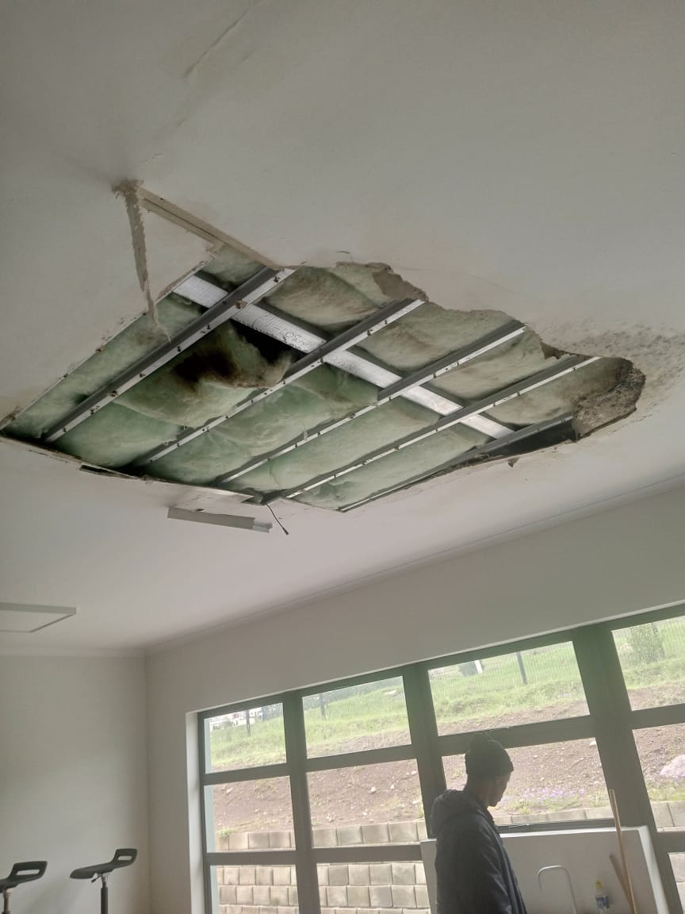
Figure 1. Damage to ceiling due to roof leaks.
- Loose and/or missing special timber ceiling panels in Foyer to be replaced. The timber panel ceiling in the foyer has fallen down and the panel needs to be replaced with a new matching panel. The existing ceiling finish can be seen in Figure 2.
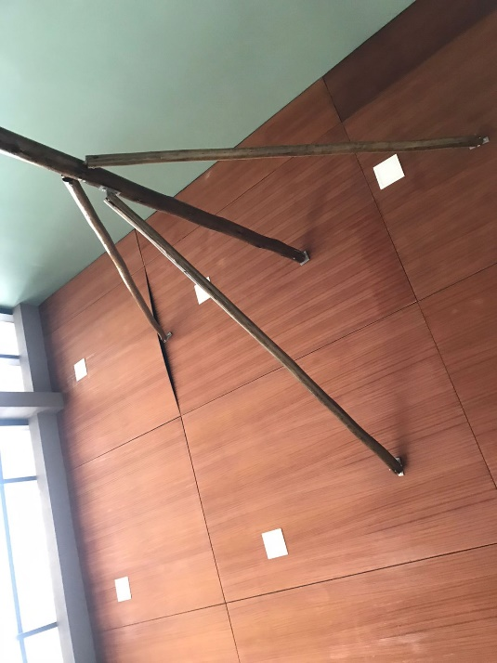
Figure 2. Existing timber ceiling panels in foyer area.
- Exterior walls of the energy hub building to be prepared and painted (the wall substrate is an alternative building technology with a plaster finish. The paint is to be a suitable exterior acrylic wall paint. Flashing to also be repaired or replaced (see Figure 4).
Figure 3. Exterior wall to be painted.
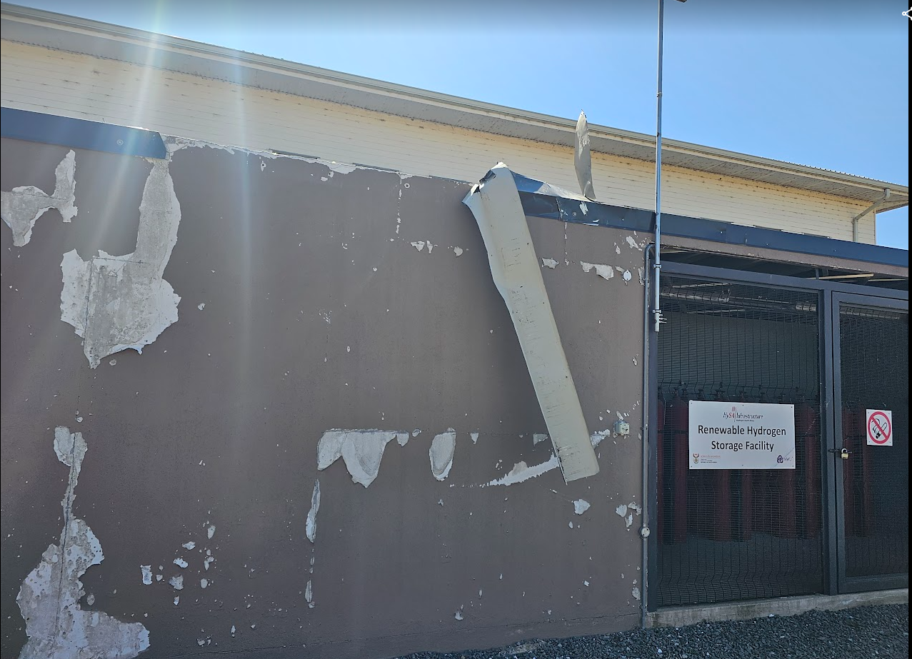
Figure 4. Exterior wall of energy hub to be repainted and flashing to be repared.
- Repair of epoxy flooring that has cracked and lifted in various places (at least five patches, such as shown in Figure 5) in the exhibition area and passages. Where necessary, the sub-base is to be corrected and patches are to be neatly cut out.
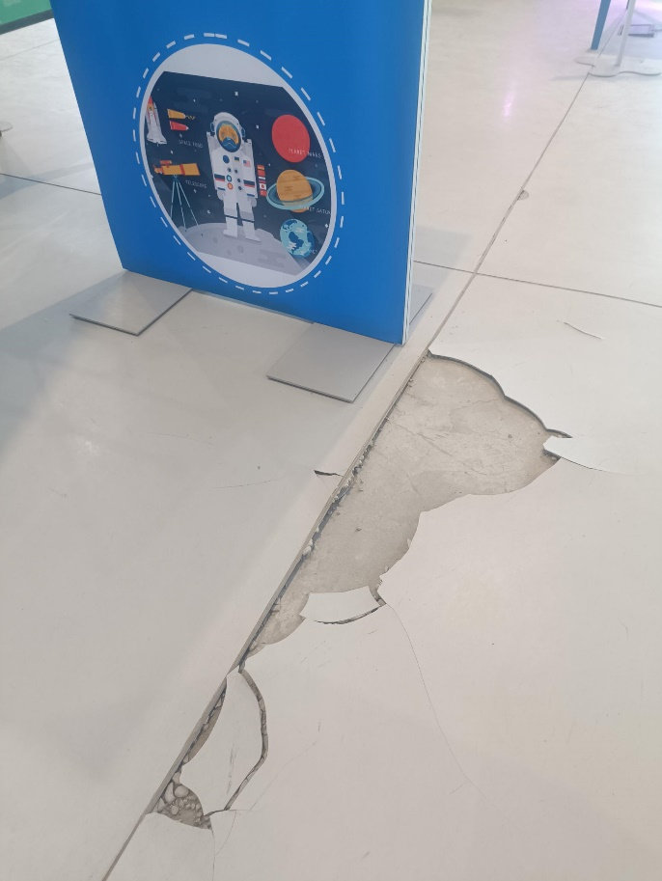
Figure 5. Example of epoxy floor cracks

- .

Annexure B
Pricing Schedule

Item No | Description | Quantitity | Unity Price  (VAT Excl) | Total Price  (VAT Excl)
1.1 | Repair of roof leaks over classrooms & ablutions.
1.2 | Repair of resultant damage to ceilings and other elements.
3 | Replacement of timber ceiling panel(s) in the foyer.
3 | Painting of exterior walls of energy hub building (including preparatory work).
5 | Repair of epoxy flooring to match existing specification, including preparatory work
Total Price (VAT Excl)
VAT (15%)
Total Price (VAT Incl)
NB: Place N/A on the pricing schedule if the bidder is choosing to only quote on certain items.
Annexure C
Standard Bidding Document (SBD) 1

PART A: INVITATION TO BID

YOU ARE HEREBY INVITED TO BID FOR REQUIREMENTS OF THE CSIR
BID NUMBER: | RFQ6229/16/02/2024 |  |  | CLOSING DATE: |  | 16/02/2024 |  |  | CLOSING TIME: |  |  | 16h30
DESCRIPTION | For the Building Maintenance and Repair at the Cofimvaba Science Centre
BID RESPONSE DOCUMENTS MAY BE DEPOSITED IN THE BID BOX SITUATED AT (STREET ADDRESS)
The CSIR requires that all tender submissions be submitted electronically to tender@csir.co.za. Should tender file size exceed 25MB, bidders submit tender in multiple emails. Use the tender number RFQ 6229/16/02/2024 and description of the tender as the subject on your email.

BIDDING PROCEDURE ENQUIRIES MAY BE DIRECTED TO |  |  |  |  | TECHNICAL ENQUIRIES MAY BE DIRECTED TO:
CONTACT PERSON |  |  | Jane Mahlangu |  | CONTACT PERSON |  |  |  |  |  | Coralie Van Reenen
TELEPHONE NUMBER |  |  | N/A |  | TELEPHONE NUMBER |  |  |  |  |  | N/A
FACSIMILE NUMBER |  |  | N/A |  | FACSIMILE NUMBER |  |  |  |  |  | N/A
E-MAIL ADDRESS |  |  | tender@csir.co.za |  | E-MAIL ADDRESS |  |  |  |  |  | tender@csir.co.za
SUPPLIER INFORMATION
NAME OF BIDDER
POSTAL ADDRESS
STREET ADDRESS
TELEPHONE NUMBER |  | CODE |  |  |  | NUMBER
CELLPHONE NUMBER
FACSIMILE NUMBER |  | CODE |  |  |  | NUMBER
E-MAIL ADDRESS
VAT REGISTRATION NUMBER
SUPPLIER COMPLIANCE STATUS |  | TAX COMPLIANCE SYSTEM PIN: |  |  | OR |  | CENTRAL SUPPLIER DATABASE No: | MAAA
- ARE YOU THE ACCREDITED REPRESENTATIVE IN SOUTH AFRICA FOR THE GOODS /SERVICES /WORKS OFFERED? |  | Yes No  [IF YES ENCLOSE PROOF] |  |  | - ARE YOU A FOREIGN BASED SUPPLIER FOR THE GOODS /SERVICES /WORKS OFFERED? |  |  |  |  | Yes No  [IF YES, ANSWER THE QUESTIONNAIRE BELOW]
QUESTIONNAIRE TO BIDDING FOREIGN SUPPLIERS
IS THE ENTITY A RESIDENT OF THE REPUBLIC OF SOUTH AFRICA (RSA)? YES NO
DOES THE ENTITY HAVE A BRANCH IN THE RSA? YES NO
DOES THE ENTITY HAVE A PERMANENT ESTABLISHMENT IN THE RSA? YES NO
DOES THE ENTITY HAVE ANY SOURCE OF INCOME IN THE RSA? YES NO
IS THE ENTITY LIABLE IN THE RSA FOR ANY FORM OF TAXATION? YES NO
IF THE ANSWER IS “NO” TO ALL OF THE ABOVE, THEN IT IS NOT A REQUIREMENT TO REGISTER FOR A TAX COMPLIANCE STATUS SYSTEM PIN CODE FROM THE SOUTH AFRICAN REVENUE SERVICE (SARS) AND IF NOT REGISTER AS PER 2.3 BELOW.

PART B: TERMS AND CONDITIONS FOR BIDDING
- BID SUBMISSION:
  - BIDS MUST BE DELIVERED BY THE STIPULATED TIME TO THE CORRECT ADDRESS. LATE BIDS WILL NOT BE ACCEPTED FOR CONSIDERATION.
  - ALL BIDS MUST BE SUBMITTED ON THE OFFICIAL FORMS PROVIDED–(NOT TO BE RE-TYPED) OR IN THE MANNER PRESCRIBED IN THE BID DOCUMENT.
  - THIS BID IS SUBJECT TO THE PREFERENTIAL PROCUREMENT POLICY FRAMEWORK ACT, 2000 AND THE PREFERENTIAL PROCUREMENT REGULATIONS, 2022, THE GENERAL CONDITIONS OF CONTRACT (GCC) AND, IF APPLICABLE, ANY OTHER SPECIAL CONDITIONS OF CONTRACT.
  - THE SUCCESSFUL BIDDER WILL BE REQUIRED TO FILL IN AND SIGN A WRITTEN CONTRACT FORM (SBD7).

- TAX COMPLIANCE REQUIREMENTS
- BIDDERS MUST ENSURE COMPLIANCE WITH THEIR TAX OBLIGATIONS.
- BIDDERS ARE REQUIRED TO SUBMIT THEIR UNIQUE PERSONAL IDENTIFICATION NUMBER (PIN) ISSUED BY SARS TO ENABLE THE ORGAN OF STATE TO VERIFY THE TAXPAYER’S PROFILE AND TAX STATUS.
- APPLICATION FOR TAX COMPLIANCE STATUS (TCS) PIN MAY BE MADE VIA E-FILING THROUGH THE SARS WEBSITE WWW.SARS.GOV.ZA.
- BIDDERS MAY ALSO SUBMIT A PRINTED TCS CERTIFICATE TOGETHER WITH THE BID.
- IN BIDS WHERE CONSORTIA / JOINT VENTURES / SUB-CONTRACTORS ARE INVOLVED, EACH PARTY MUST SUBMIT A SEPARATE TCS CERTIFICATE / PIN / CSD NUMBER.
- WHERE NO TCS PIN IS AVAILABLE BUT THE BIDDER IS REGISTERED ON THE CENTRAL SUPPLIER DATABASE (CSD), A CSD NUMBER MUST BE PROVIDED.
- NO BIDS WILL BE CONSIDERED FROM PERSONS IN THE SERVICE OF THE STATE, COMPANIES WITH DIRECTORS WHO ARE PERSONS IN THE SERVICE OF THE STATE, OR CLOSE CORPORATIONS WITH MEMBERS PERSONS IN THE SERVICE OF THE STATE.”

NB: FAILURE TO PROVIDE / OR COMPLY WITH ANY OF THE ABOVE PARTICULARS MAY RENDER THE BID INVALID.

SIGNATURE OF BIDDER: ……………………………………………

CAPACITY UNDER WHICH THIS BID IS SIGNED: ……………………………………………
(Proof of authority must be submitted e.g. company resolution)

DATE: …………………………………………...

Annexure D
Standard Bidding Document (SBD) 4

BIDDER’S DISCLOSURE

- PURPOSE OF THE FORM
Any person (natural or juristic) may make an offer or offers in terms of this invitation to bid. In line with the principles of transparency, accountability, impartiality, and ethics as enshrined in the Constitution of the Republic of South Africa and further expressed in various pieces of legislation, it is required for the bidder to make this declaration in respect of the details required hereunder.

Where a person/s are listed in the Register for Tender Defaulters and / or the List of Restricted Suppliers, that person will automatically be disqualified from the bid process.

- Bidder’s declaration
2.1 Is the bidder, or any of its directors / trustees / shareholders / members / partners or any person having a controlling interest in the enterprise,
employed by the state? YES /NO
2.1.1 If so, furnish particulars of the names, individual identity numbers, and, if applicable, state employee numbers of sole proprietor/ directors / trustees / shareholders / members/ partners or any person having a controlling interest in the enterprise, in table below.
Full Name | Identity Number | Name of State institution

2.2 Do you, or any person connected with the bidder, have a relationship with any person who is employed by the procuring institution? YES /NO
2.2.1 If so, furnish particulars:
……………………………………………………………………………………
……………………………………………………………………………………

2.3 Does the bidder or any of its directors / trustees / shareholders / members / partners or any person having a controlling interest in the enterprise have any interest in any other related enterprise whether or not they are bidding for this contract? YES /NO

    - If so, furnish particulars:
…………………………………………………………………………….
…………………………………………………………………………….

- DECLARATION

I, the undersigned, (name)………………………………………………………in submitting the accompanying bid, do hereby make the following statements that I certify to be true and complete in every respect:

3.1 I have read and I understand the contents of this disclosure;
3.2 I understand that the accompanying bid will be disqualified if this disclosure is found not to be true and complete in every respect;
3.3 The bidder has arrived at the accompanying bid independently from, and without consultation, communication, agreement or arrangement with any competitor. However, communication between partners in a joint venture or consortium will not be construed as collusive bidding.
3.4 In addition, there have been no consultations, communications, agreements or arrangements with any competitor regarding the quality, quantity, specifications, prices, including methods, factors or formulas used to calculate prices, market allocation, the intention or decision to submit or not to submit the bid, bidding with the intention not to win the bid and conditions or delivery particulars of the products or services to which this bid invitation relates.
3.4 The terms of the accompanying bid have not been, and will not be, disclosed by the bidder, directly or indirectly, to any competitor, prior to the date and time of the official bid opening or of the awarding of the contract.

3.5 There have been no consultations, communications, agreements or arrangements made by the bidder with any official of the procuring institution in relation to this procurement process prior to and during the bidding process except to provide clarification on the bid submitted where so required by the institution; and the bidder was not involved in the drafting of the specifications or terms of reference for this bid.

  - I am aware that, in addition and without prejudice to any other remedy provided to combat any restrictive practices related to bids and contracts, bids that are suspicious will be reported to the Competition Commission for investigation and possible imposition of administrative penalties in terms of section 59 of the Competition Act No 89 of 1998 and or may be reported to the National Prosecuting Authority (NPA) for criminal investigation and or may be restricted from conducting business with the public sector for a period not exceeding ten (10) years in terms of the Prevention and Combating of Corrupt Activities Act No 12 of 2004 or any other applicable legislation.

I CERTIFY THAT THE INFORMATION FURNISHED IN PARAGRAPHS 1, 2 and 3 ABOVE IS CORRECT.
I ACCEPT THAT THE STATE MAY REJECT THE BID OR ACT AGAINST ME IN TERMS OF PARAGRAPH 6 OF PFMA SCM INSTRUCTION 03 OF 2021/22 ON PREVENTING AND COMBATING ABUSE IN THE SUPPLY CHAIN MANAGEMENT SYSTEM SHOULD THIS DECLARATION PROVE TO BE FALSE.

……………………………… ..……………………………………………
Signature Date

……………………………… ………………………………………………
Position Name of bidder

Annexure E
Preference Points Award Form in Terms of the Preferential Procurement Regulations 2022

This preference form must form part of all bids invited. It contains general information and serves as a claim form for the preference points allocated on the basis of specific goals outlined in point 3 below.

NB: BEFORE COMPLETING THIS FORM, BIDDERS MUST STUDY THE GENERAL CONDITIONS, DEFINITIONS AND DIRECTIVES APPLICABLE IN RESPECT OF SPECIFIC GOALS, AS PRESCRIBED IN THE PREFERENTIAL PROCUREMENT REGULATIONS, 2022

- GENERAL CONDITIONS
  - The following preference point systems are applicable to this bid:
- the 80/20 system for requirements with a Rand value of up to R50 000 000 (all applicable taxes included).

  - Points for this bid shall be awarded for:
- Price; and
- Preference Points based on specific goals.
  - The maximum points for this bid are allocated as follows:
 | POINTS
PRICE | 80
Preference Points | 20
Total points for Price and Preference Points must not exceed | 100

  - Failure on the part of a bidder to submit proof of preference points together with the bid, will be interpreted to mean that preference points are not claimed.
  - The CSIR reserves the right to require of a bidder, either before a bid is adjudicated or at any time subsequently, to substantiate any claim in regard to preferences, in any manner required by the CSIR.

- POINTS AWARDED FOR PRICE
  - THE 80/20 PREFERENCE POINT SYSTEMS
A maximum of 80 points is allocated for price on the following basis:

80/20

Where
Ps = Points scored for price of bid under consideration
Pt = Price of bid under consideration
Pmin = Price of lowest acceptable bid

- PREFERENCE POINTS AWARDED
  - In terms of Regulation 4 (2) and 4 (2) of the Preferential Procurement Regulations, preference points may be awarded to a bidder for the specific goal specified for the tender in accordance with the table below:
  - Specific goals must be determined per tender.

Specific Goals | Preference Points
Black Ownership | 20
Total | 20

  - Total preference points per specific goal to be determined per tender.

    - Total preference points per specific goal to be awarded as follows:

      - Preferential points for black ownership will be awarded as follows:

Black Ownership | % of Preferential points
Bidder with 100% black ownership | 100%
Bidder with 51% to 99% black ownership | 50%
Bidder with less than 51% black ownership | 0%

  - Joint Ventures, Consortiums and Trusts
A trust, consortium or joint venture, will qualify for preference points as a legal entity (Incorporated), provided that the entity submits its valid B-BBEE certificate. Only valid BBBEE certificates issued by SANAS accredited verification agency will be considered for allocation of points.
A trust, consortium or joint venture will qualify for preference points as an unincorporated entity, provided that the entity submits their consolidated B-BBEE scorecard as if they were a group structure and that such a consolidated B-BBEE scorecard is prepared for every separate bid. Only valid consolidated BBBEE certificates issued by SANAS accredited verification agency will be considered for allocation of points.
Bidders must submit concrete proof of the existence of joint ventures and/or consortium arrangements. The CSIR will accept signed agreements as acceptable proof of the existence of a joint venture and/or consortium arrangement. Furthermore, in bids where unincorporated joint venture and/or consortium/sub-contractors are involved, each party must submit a separate TCS PIN and CSD number.
The joint venture and/or consortium agreements must clearly set out the roles and responsibilities of the Lead Partner and the joint venture and/or consortium party. The agreement must also clearly identify the Lead Partner, who shall be given the power of attorney to bind the other party/parties in respect of matters pertaining to the joint venture and/or consortium arrangement.

  - Sub-contracting
A bidder must not be awarded preference points if it is indicated in the tender documents that such a bidder intends sub- contracting more than 25% of the value of the contract to any other enterprise that does not qualify for at least the points that such a bidder qualifies for, unless the intended sub-contractor is an EME that has the capability and ability to execute the sub-contract.
A bidder awarded a contract may not sub-contract more than 25% of the value of the contract to any other enterprise that does not have an equal or higher B-BBEE status level than the bidder concerned, unless the contract is sub-contracted to an EME that has the capability and ability to execute the sub-contract.

- BID DECLARATION
Bidders who claim points in respect of specific goals must submit the following documents:
Mandatory documents to claim preference points | Submitted
 | Yes  √ | No  √
Valid copy of BBBEE certificate/ sworn affidavit to claim Black Ownership, Black Woman Ownership, Black Youth Ownership, Disability Ownership and RDP (EMEs and QSEs) preference points

DECLARATION WITH REGARD TO COMPANY/FIRM
Name of company/firm:…………………………………………………………………………….
VAT registration number:……………………………………….…………………………………
Company registration number:…………….……………………….…………………………….
I/we, the undersigned, who is / are duly authorised to do so on behalf of the company/firm, certify that the documents submitted to claim preference points based on the specific goals are valid, and I / we acknowledge that:

- The information furnished is true and correct;
- The preference points claimed are in accordance with the General Conditions as indicated in paragraph 3 of this form;
- In the event of a contract being awarded as a result of points claimed as shown in paragraphs 3, the contractor may be required to furnish further documentary proof to the satisfaction of the CSIR that the awarded are correct;
- If any document is obtained on a fraudulent basis or any of the conditions of contract have not been fulfilled, the CSIR may, in addition to any other remedy it may have –

  - disqualify the person from the bidding process;
  - recover costs, losses or damages it has incurred or suffered as a result of that person’s conduct;
  - cancel the contract and claim any damages which it has suffered as a result of having to make less favourable arrangements due to such cancellation;
  - recommend that the bidder or contractor, its shareholders and directors, or only the shareholders and directors who acted on a fraudulent basis, be restricted by the National Treasury from obtaining business from any organ of state for a period not exceeding 10 years, after the audi alteram partem (hear the other side) rule has been applied; and
  - forward the matter for criminal prosecution.
- If the CSIR is of the view that a bidder submitted false information regarding a specific goal, it must—
- inform the bidder accordingly; and
- give the bidder an opportunity to make representations within 14 days as to why the tender may not be disqualified or, if the tender has already been awarded to the bidder, the contract should not be terminated in whole or in part.
- After considering the representations referred to in subregulation (v)(b), the CSIR may, if it concludes that such information is false—
- disqualify the bidder or terminate the contract in whole or in part; and
- if applicable, claim damages from the bidder.

……………………………………….
SIGNATURE(S) OF BIDDERS(S)

DATE: …………………………………..

ADDRESS…………………………………..
…………………………………..
…………………………………..

WITNESSES

- ……………………………………..
- …………………………………….

MUTUAL NON-DISCLOSURE AGREEMENT

- Preamble
The Parties as identified herein are engaged in discussions relating to their potential collaboration in the Field as likewise described therein; are by virtue thereof are required to disclose Confidential Information to one another, and have agreed to do so subject to the terms and conditions as set out in this agreement.

- Definitions
  - The following words and/or phrases, when used in this agreement, shall have the following meanings:
    - “Confidential Information” shall mean all scientific, technical, business, financial, past, present or future research, development, business activities, products, services and technical knowledge or marketing information , whether inside or outside the Field, which one party (the “Disclosing Party”) discloses to the other party (the “Receiving Party”) in connection with the discussions, and either has been identified in writing as confidential or is of such a nature (or has been disclosed in such a way) that it should be obvious to the Receiving Party that it constitutes Confidential Information. (Without limiting the generality of the aforegoing, “Confidential Information” shall include any information that falls within the definition of ‘Personal Information’
    - “Disclosing Party” shall mean the Party disclosing Confidential Information under this agreement;
    - “Disclosing Purpose” shall mean, as pertains to any particular joint opportunity(ies) in the Field, the discussions held or to be held between the Parties regarding their possible collaboration and future working relationship with regards to any such opportunity(ies);
    - “Effective Date’ shall mean the date of the commencement of this agreement herein”;
    - “Notice” shall mean a written document addressed by one Party to the other and either delivered by hand; sent per registered post or telefaxed to the addresses as indicated herein”;
    - “Personal Information” means any information that falls within the definition of ‘Personal Information’ as defined in the Protection of Personal Information Act, No 4 of 2013 (“POPI”);
    - “Receiving Party” shall mean the Party receiving Confidential Information under this agreement;
“Responsible Party” means a public or private body or any other person which, alone or in conjunction with others, determines the purpose of and means for processing personal information, as defined in POPI.

- Obligation of Confidentiality
  - The Receiving Party undertakes and agrees:
    - to use the Disclosing Party‘s Confidential Information only to give effect to the Disclosing Purpose;
    - to hold in strict confidence and not to publish or disclose to any unauthorised third parties any of the Confidential Information of the Disclosing Party without the prior written consent of the Disclosing Party;
    - to use the same degree of care (and in any event not less than reasonable care) to safeguard the confidentiality of the Disclosing Party’s Confidential Information that it uses to protect its own information of like kind;
    - to limit any disclosure of such Confidential Information only to those of its employees and professional advisors who have a specific need –to- know to access such Confidential Information and either entered into a written agreement which impose, or are otherwise bound by the same restrictions as those imposed upon it by virtue of this agreement;
    - not to disclose or reveal to any third party, whomsoever, either the fact that discussions or negotiations are taking, or have taken, place between the Parties; the content of any such discussions, or other facts relating to the Disclosing Purpose;
    - on termination of this agreement, to act with the Disclosing Party’s Confidential Information in accordance with a Notice delivered to it by the Disclosing Party, and if no such Notice is delivered to the Recipient, to destroy the Disclosing Party’s Confidential Information in a similar manner to which it would destroy its own Confidential Information.

- Protection of Personal Information
  - The Party(ies) undertake(s) to:-
    - comply with the provisions of POPI as well as all applicable legislation as amended or substituted from time to time;
    - treat all Personal Information strictly as defined within the parameters of POPI;
    - process Personal Information only in accordance with the consent it was obtained for, for the purpose agreed, any lawful and reasonable written instructions received from the applicable Responsible Party and as permitted by law;
    - process Personal Information in compliance with the requirements of all applicable laws;
    - secure the integrity and confidentiality of any Personal Information in its possession or under its control by taking appropriate, reasonable technical and organisational measures to prevent loss, damage, unauthorised destruction, access, use, disclosure or any other unlawful processing of Personal Information;
    - not transfer any Personal Information to any third party in a foreign country unless such transfer complies with the relevant provisions of POPI regarding transborder information flows; and
    - not retain any Personal Information for longer than is necessary for achieving the purpose in terms of this Agreement or in fulfilment of any other lawful requirement.
  - The Party(ies) undertake(s) to ensure that all reasonable measures are taken to:
    - identify reasonably foreseeable internal and external risks to the Personal Information in its possession or under its control;
    - establish and maintain appropriate security safeguards against the identified risks;
    - regularly verify that the security safeguards are effectively implemented;
    - ensure that the security safeguards are continually updated in response to new risks or deficiencies in previously implemented safeguards;
    - provide immediate notification to the Responsible Party if a breach in information security or any other applicable security safeguard occurs; provide immediate notification to the Responsible Party where there are reasonable grounds to believe that the Personal Information has been accessed or acquired by any unauthorised person;
    - remedy any breach of a security safeguard in the shortest reasonable time and provide the Responsible Party with the details of the breach and, if applicable, the reasonable measures implemented to address the security safeguard breach;
    - provide immediate notification to the Responsible Party where either party has, or reasonably suspects that, Personal Information has been processed outside of the purpose agreed to or consented to;
    - provide the Responsible Party, upon request, with all information of any nature whatsoever relating to the processing of the Personal Information for the purpose in terms of this Agreement and any applicable law; and
    - notify the CSIR, if lawful, of receipt of any request for access to Personal Information, in its possession and relating to the CSIR.
  - The CSIR reserves the right to inspect the Personal Information processing operations, as well as the technical and organisational information security measures employed by the contracting Party to ensure compliance with the provisions of clause 4.
  - The provisions of clause 4 shall survive the termination of this Agreement, regardless of cause, in perpetuity.

- Exclusions
  - The Receiving Party recognises that this agreement is not intended to restrict use or disclosure of any portion of the Disclosing Party’s Confidential Information which:
    - is as at the Effective Date, or later, made known to the public or otherwise enters the public domain through no default by the Receiving Party of its obligations under this Agreement;
    - it can show was in its possession prior to the earliest disclosure by the Disclosing Party, as evidenced by written documents in its files;
    - is rightfully received by it from a third party having no obligation of confidentiality to the Disclosing Party;
    - is independently developed by the Receiving Party by a person(s) who did not have access to the Confidential Information of the Disclosing Party;
    - is disclosed by the Receiving Party after receipt of written permission from the Disclosing Party; or
    - it is requested or required by subpoena, court order, or similar process to disclose, provided that, in such an event, it will provide the Disclosing Party with prompt written notice of such request(s) so that the latter may seek an appropriate protective order and/or waive the Receiving Party’s compliance with the provisions of this agreement.

- Ownership and Provision of Infomration
  - The Disclosing Party shall retain ownership of all its Confidential Information as disclosed hereunder.
  - Nothing contained in this agreement or in any disclosures made hereunder shall create or imply, or be construed as to grant to the Receiving Party any license or other rights in or to the Confidential Information and/or any intellectual property rights attached thereto, or act as a waiver of any rights that the Disclosing Party may have to prevent infringement or misappropriation of any patents, patent applications, trademarks, copyright, trade secrets, know-how or other intellectual property rights owned or controlled by the Disclosing Party as at the Effective Date.
  - The Disclosing Party provides the Confidential Information "as is" and accordingly no disclosure thereof by it hereunder shall constitute any representation, warranty, assurance, guarantee or inducement by such Disclosing Party with respect to infringement of patents or other rights of third parties, nor is any warranty or representation as to the accuracy, completeness, or technical or scientific quality of any of the Disclosing Party’s Confidential Information provided hereunder. (For the avoidance of doubt it is stated expressly that the Disclosing Party neither makes, nor have made, any representation or warranty as to the merchantability or fitness for a particular purpose of any Confidential Information disclosed hereunder).

- Term of Obligation
  - The Parties’ obligations concerning non-disclosure of Confidential Information contained in the above clauses shall commence on the Effective Date and shall continue for five (5) years from the date of each disclosure, unless otherwise agreed between the parties in writing, where after such obligations shall forthwith terminate.

- No Violation
  - Each party represents that its compliance with the provisions of this agreement will not violate any duty which such party may have towards any third party, including obligations concerning the provision of services to others, confidentiality of information and assignment of inventions, ideas, patents or copyright.

- Breach
  - It is acknowledged that the breach of this agreement by the Receiving Party would cause the Disclosing Party irreparable injury not compensable in monetary damages alone. Accordingly, in the event of a breach, or a threat of a breach, the Disclosing Party, in addition to its other remedies, is entitled to a restraining order, preliminary injunction or similar relief so as to specifically enforce the terms of this agreement or prevent, cure or reduce the adverse effects of the breach.

- DOMICILIUM CITANDI ET EXECUTANDI
  - The Parties hereto respectively choose as their domicilium citandi et executandi for all purposes of, and in connection with this agreement, the physical addresses and contact details stated herein.

- Notices
  - Any Notice to be given hereunder shall be given in writing and may be given either personally or may be sent by post or facsimile and addressed to the relevant party at its domicilium citandi et executandi address as chosen herein. Any notice given by post shall be deemed to have been served on the expiry of 7 (seven) working days after same is posted by recorded delivery post or air mail. Any notice delivered personally or sent by facsimile shall be deemed to have been served at the time of delivery or sending.

- Governing Law and Jurisdiction
  - This agreement will be governed and construed by the laws of the Republic of South Africa and the Parties hereby submit to the exclusive jurisdiction of the South African courts to hear any dispute arising therefrom which the Parties are unable to settle amicably.

- General
  - This agreement comprises the entire agreement between the parties concerning the subject matter and supersedes all prior oral and written agreements between them.
  - No waiver, alteration or cancellation of any of the provisions of the Agreement shall be binding unless made in writing and signed by the party to be bound.
  - The parties hereby warrant that the officials signing this agreement have the power to do so on behalf of the parties.
  - No public announcement, such as a media release, or disclosure beyond those disclosures authorised for Confidential Information hereunder may be made by either party concerning this agreement without the prior written approval of the other party.
  - Neither party is, by virtue of this agreement, authorised to use the name, logo(s) or trademarks of the other in connection with any advertising, publicity, marketing or promotional materials or activities, or for any other purpose whatsoever, without the prior written consent of the other party. For purposes of this clause, it is also recognised that, under the provisions of section 15 (1) of the Merchandise Marks Act, Act No 17 of 1941 of the Republic of South Africa, the use of the abbreviation of the name of the Council for Scientific and Industrial Research, "WNNR" and CSIR , is prohibited in connection with any trade, business, profession or occupation or in connection with a trade mark, mark or trade description applied to goods, other than with the consent of the CSIR.
  - Both Parties shall remain free to use, in the normal course of its business, its general knowledge, skills and experience incurred before, during or after the discussions envisaged hereunder. (To this end, it is also recorded that nothing in this Agreement shall be construed as constituting an exclusive arrangement between the parties and both Parties shall remain free to explore market opportunities in the Field, unless otherwise agreed to in writing in a subsequent agreement.)

ANNEXURE F: MUTUAL NDA
- Parties to the NDA

THE CSIR, a statutory council, duly established under Act 46 of 1988,
and
The Bidder (Name)…………………………………………………………………………
Company registration number:………… ……………………………………………, with limited liability duly incorporated under the applicable laws of the Republic of South Africa herein represented by ………………………………… ………………………… in his/her capacity as ………………………… …………………… …………………… and he/she being duly authorised thereto.
- Contact Details for Purposes of Clause 10:

  - The CSIR
Physical Address:
Meiring Naude Road
Brummeria
Pretoria
0002

Postal Address:
PO BOX 395
Pretoria
0001

Email: Tender@csir.co.za

The Bidder (Name)………………………………………………………..………………
Physical Address: ………………………………………………………… ………………

Postal Address: …………………………………………………………… ………………

Email: ……………………………………………… …………………………..……………

- Signature (Bidder): …………………………………………………………………

SIGNED ON THIS THE………………DAY OF…………………….AT…………………………………… IN THE PRESENCE OF THE FOLLOWING WITNESSES:

1. …………………………………………………
2. …………………………………………………

the power, by one person or a group of persons holding the majority of the equity of an enterprise, alternatively, the person/s having the deciding vote or power to influence or to direct the course and decisions of the enterprise.
Joint venture or Consortium means an association of persons for the purpose of combining their expertise, property, capital, efforts, skill and knowledge in an activity for the execution of a contract.
Joint venture or Consortium means an association of persons for the purpose of combining their expertise, property, capital, efforts, skill and knowledge in an activity for the execution of a contract.
In case of unincorporated trust, consortium or joint venture, they must submit their consolidated B-BBEE scorecard with submitting their individual B-BBEE Certificate or Sworn Affidavit, and each party must submit a separate TCS PIN and CSD number. In case of sub-contracting both parties must submit copies of their valid BBBEE certificates

